Before reading look at the front cover and read the title. Ask your child some questions:
What sort of creature do you think this is?
What do you think will happen in this story?

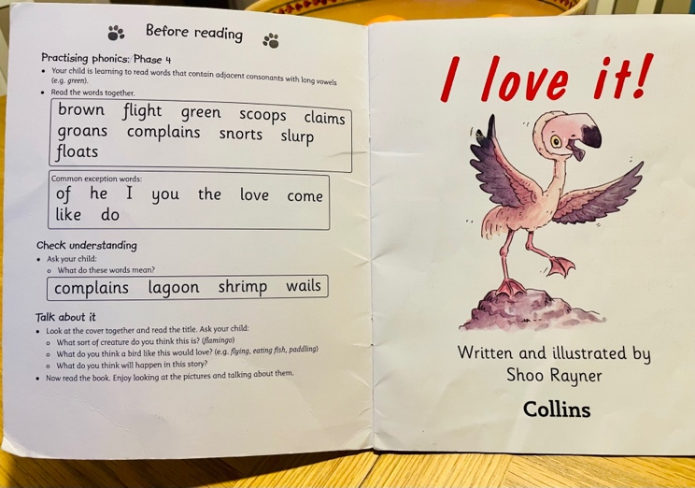

Practise the phonics on the inside page of the front cover:
Read the words together.
Read the common exception words.
Check their understanding of what these words mean.

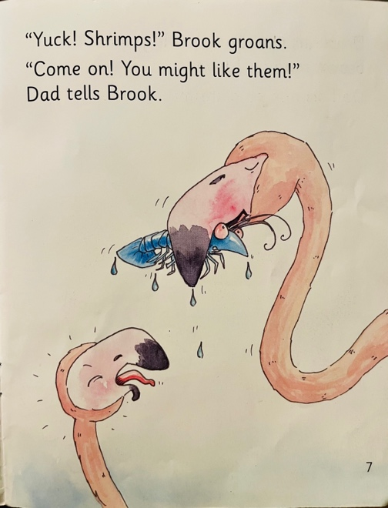
Now read the book. Look at the pictures together as your child reads. Talk about what is happening. Point out punctuation.

The first read might be a bit slower as they will need to decode more. You don’t need to read the whole book at once, stop after about 15 mins and carry on from where you read up to the next day.

Additional ways to extend your child’s reading
Extend Vocabulary
Focus on specific words
What words could we use instead of hunts?
On pg 7, Brook is groans in complaint. What tone of voice would you use if you were complaining?

Develop fluency
Read the book together using different voices for the characters.

Comprehension
Retell the story in their own words.
Look at the inside of the back cover and find the comprehension questions specific to the book your child is reading.

