Welcome to Moulsham Infant School.
We admit 90 children each year, into our three EYFS classes. We pride ourselves on our friendly atmosphere and high expectations. Our children enjoy coming to school and make good progress in all areas. Please feel free to make an appointment to visit us. Jane Landa-Arrese, Headteacher

Hive- Multi Academy Trust

From April 1st 2025 Moulsham Infant School became part of the HIVE Multi-academy Trust. This collaboration realtionship helps us to improve outcomes for children, support staff with professional developemnt and enable leaders to share best practice.

School Organisation

Moulsham Infant School is situated on a site together with Moulsham Junior School and Moulsham High School. The three schools and Oaklands Infant School work together wherever possible. Children enter our school at the beginning of the school year in which they are five, with the youngest children having the option to attend part-time in their first term. On entry, children follow the Early Years Foundation Stage Curriculum and then work on Key Stage 1 of the National Curriculum in Years One and Two. At seven, children may transfer to Moulsham Junior School, spending four years there before moving on to secondary school at eleven years of age.

Reception Children

Our main priority as a school is to ensure that your child is in a happy and secure environment and therefore able to concentrate on learning. We are aware that young children starting school worry about such things as being able to find the toilet and cloakroom. In our school, there are these facilities for reception children in their classrooms.

Curriculum

Our motto at Moulsham Infant School is to Motivate Inspire and Succeed. We motivate through our creative curriculum, which is both skills based and knowledge rich. We inspire through engaging and enthusiastic teaching, excellent pedagogy and children’s interest. Success is seen by the children’s attitudes to learning and school and their learning behaviours such as Independence, Curiosity, Ambition, Resilience and showing Empathy (I CARE). This is underpinned by encouraging the children to ‘be the best they can be’ through a growth mindset approach. Consistent, positive language is used such as ‘we can’t do it yet’ and ‘we always keep trying’.

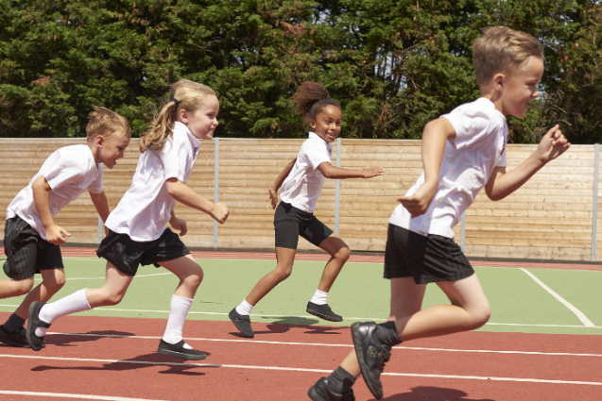

“Leaders have constructed a curriculum that goes beyond the expectations of the National Curriculum”
Ofsted 2023

The Early Years Foundation Stage (EYFS) Curriculum

The EYFS curriculum is underpinned by the following over-arching principles.
A Unique Child – Every child is a unique child who is constantly learning and can be resilient, capable, confident and self-assured.
Positive Relationships – Children learn to be strong and independent through positive relationships.
Enabling Environment with teaching and support from adults – Children learn and develop well in enabling environments, with teaching and support from adults who respond to their individual interests and needs and help them to build their learning over time.
Learning and Development – Children develop and learn at different rates

Our curriculum is planned around the seven areas of learning, as follows:
Prime Areas
1. Communication and language.
2. Personal, social and emotional development.
3. Physical development.
Specific Areas
4. Literacy
5. Mathematics
6. Understanding the world
7. Expressive arts and design
We deliver the curriculum through a mixture of teacher led lessons and continuous provision, based around a variety of themes. Using what the children are already deeply involved in, teachers and LSAs closely observe the children and interact with them to draw out their knowledge, building on it there and then (in the moment). Outdoor learning is highly valued and we have free flow between the indoor and the outdoor classrooms.

“I have been very happy with the quality of teaching and learning, especially the ‘play-based’ learning in EYFS”
Parent Survey 2023

The Key Stage 1 Curriculum (KS1)

In Key Stage 1, we follow the National Curriculum, which consists of core subjects- English, Maths and Science. It also incorporates foundation subjects which include Computing, Art, Design and Technology, History, Geography, Relationship, Sex and Health Education (RSHE), Religious Education (RE), Music and Physical Education (PE). We enrich this curriculum through our exciting curriculum that encourages creativity, leads children to question and investigate and taps into personal learning and thinking skills.

This year we are moving towards a more topic-based approach to learning, which means children explore subjects through exciting, cross-curricular themes that spark curiosity and creativity. Each term, a new topic—such as "The Great Fire" or "Exploration"—guides the learning across subjects like English, geography, history, art, and DT. This method helps children make meaningful connections between ideas, deepens their understanding, and encourages them to ask questions and investigate the world around them. By learning through topics that are relevant and engaging, children develop a love for learning and build essential skills in a fun, purposeful way, whilst still ensuring they are learning the key skills and knowledge as outlined in the national curriculum.

There are regular opportunities for parents to be involved in and informed about their child’s curriculum, for example by regular updates on monthly newsletters and class assemblies. Details of our curriculum and expectations for each year group can also be found on our website at www.moulsham-inf.essex..sch.uk.


ENGLISH English is the base on which every other subject builds. Learning English means learning to communicate through reading, writing, speaking and listening. Our aim is to develop in our children all of these skills. Our KS1 English curriculum is based upon the National Curriculum, but we have adapted and enhanced it to make our teaching and learning cross-curricular, innovative, creative and fun.

READING At Moulsham Infant School, we believe that all our children can become fluent readers and writers. This is why we teach reading through Little Wandle Letters and Sounds Revised, which is a systematic and synthetic phonics programme. We start teaching phonics in Reception and follow the Little Wandle Letters and Sounds Revised progression, which ensures children build on their growing knowledge of the alphabetic code, mastering phonics to read and spell as they move through school.
At Moulsham Infant School, we value reading as a crucial life skill. By the time children leave us, they read confidently for meaning and regularly enjoy reading for pleasure. Our readers are equipped with the tools to tackle unfamiliar vocabulary. We encourage our children to see themselves as readers for both pleasure and purpose. We work hard to grow our Reading for Pleasure ethos:
- We read to children every day. We choose these books carefully as we want children to experience a wide range of books, including books that reflect the children at Moulsham Infant School and our local community as well as books that open windows into other worlds and cultures.
- Every classroom has an inviting book corner that encourages a love for reading. We curate these books and talk about them to entice children to read a wide range of books.
- In Reception, children have access to the reading corner every day in their free flow time and the books are continually refreshed.
- Children from Reception onwards have a home reading record. The parent/carer records comments to share with the adults in school.
- The school library is made available for classes to use at specific times. During this time children are allowed to choose their own reading books from the appropriate stage, as well as a book to share with someone at home – we call these Treasure books.
- Children across the school have regular opportunities to engage with a wide range of Reading for Pleasure events (book fairs, author visits and workshops, national events etc.).

“Pupils are taught to read as soon as they start school. Teachers ensure pupils’ reading books are matched to their phonics knowledge.”
Ofsted 2023

WRITING

It is our goal for the children to communicate clearly and confidently through their writing. Children are encouraged to write for a range of purposes and readership.
We encourage children to develop their written skills through an ‘emergent writing’ process and value the ability for them to communicate through their own mark marking. Our approach to writing has been developed carefully, to ensure we provide children with exciting, purposeful opportunities to write. We ensure children learn about a range of genres and have a rich reading spine that we use as exemplar texts. We encourage children to use drama, actions and collaborative discussions as pre-writing activities to support them with the planning process. Children in key stage one write fiction, non-fiction, and poetry! We are very proud of our writing. To develop our children as writers we:
• begin in early years supporting the development of children’s fine motor skills through a range of activities, ensuring they are physically ‘ready to write’. This continues into key stage one where appropriate.
• provide experiences where the children can acquire confidence and a positive attitude to writing such as through ‘helicopter stories’ in the early years where adults support children by scribing their stories in a shared writing process.
• develop and sustain writing skills by providing opportunities for children to write for a range of purposes and audiences.
• use guided writing sessions to model writing skills, teaching children how to compose, amend and revise their writing.
• teach children to become critical readers of their own writing by using self-evaluation and checking their work independently for sense, accuracy and meaning; teach grammar and punctuation in the context of children’s own writing, as well as through discrete lessons.
• teach children to develop their ability to organise and present imaginative and/or factual writing and poetry in different ways.
• teach strategies for spelling to enable children to become confident and competent spellers.


HANDWRITING
Letter formation is developed alongside Little Wandle letters and sounds to make links between phoneme, grapheme and letter shapes. Children are supported to develop a legible, cursive handwriting style and typing and keyboard skills. Children are taught discreet handwriting lessons in key stage one and are expected to maintain a neat, joined style throughout their writing by the end of year 2..
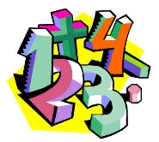
MATHEMATICS
We believe that being confident and skilled in mathematics is a key life skill and that it is our role, through the maths curriculum, to help children develop the skills and knowledge that will enable them to become fluent in the foundations of mathematics. We follow the Mastery Approach, teaching children to reason mathematically, to solve problems using their mathematical knowledge, and develop a positive and enquiring relationship with the subject. In our nurturing, stimulating and reflective environment we encourage children to become independent learners who are proud of their achievements.

“Pupils are motivated learners”
Ofsted 2023
We follow the National Curriculum and have adopted the Mastery Approach for delivering our maths curriculum in both EYFS and KS1. The Mastery Approach enables children to acquire a deep long-term, secure and adaptable understanding of the subject.
Achieving mastery means acquiring a solid understanding of the maths that has been taught, enabling them to apply concepts in a range of contexts. This sets children up with secure foundations before moving on to more advanced material.
When introducing a new concept, we use the CPA (Concrete, Pictorial, Abstract) framework.
- Concrete – children should have the opportunity to use concrete objects and manipulatives to help them understand what they are doing.
- Pictorial – alongside concrete objects, children should also use pictorial representations. These representations are then used to help reason and solve problems.
- Abstract – both concrete and pictorial representations are used to support children’s understanding of abstract methods.
We use White Rose Maths and Mastering Number to support our planning of lessons, as well as resources and materials from Active Maths, Numicon, NRICH, and NCETM. Teaching and learning aims to ensure that all pupils develop fluency, reasoning and problem-solving skills. Maths is taught both indoors and outdoors and, in all lessons, a range of resources, activities and questions are used to meet the needs of individual learners. The children work on a variety of activities, using both practical and written methods. Progress and misconceptions are identified and inform planning and interventions.


SCIENCE is a subject that develops children’s natural curiosity, where they are directed towards logical investigations, controlled observation, classification and experimentation. Science teaching aims to give all children a strong understanding of the world around them whilst acquiring specific skills and knowledge to help them to think scientifically, to gain an understanding of scientific processes and also an understanding of the uses and implications of Science, today and for the future. At Moulsham Infant School we aim to create a positive attitude to science learning by ensuring the children have the opportunities to complete practical investigations, ask questions, make predictions and explain what they observe. Throughout the year they will learn about Animals, including humans, plants and materials etc.

COMPUTING aims to give children an understanding of the digital world around them. We believe children should develop the skills needed to create digital content using text, audio and visual media, and also begin to develop computational thinking in order to solve problems. E-safety and responsible use is embedded in the curriculum. The school has a computer suite, classroom computers, Chromebooks and tablets, as well as interactive panels in each classroom.


DESIGN AND TECHNOLOGY DT encourages our children to be creative thinkers, designers and problem solvers. This involves planning, designing, making, modifying and evaluating products, using a variety of materials and resources. Design and Technology is a way of children learning about the world around them and links with other areas of our curriculum, particularly Science and Art. In EYFS, children use the indoor and outdoor classrooms to develop their designing and making skills. They learn how to handle different tools safely. This continues into KS1 where we develop the children’s skills further by engaging them in the process of planning and evaluating their work. All children have the opportunity to participate in a variety of food technology activities to develop their cooking skills and their knowledge of a healthy balanced diet.


HISTORY Through the History curriculum, we want to develop 21st century citizens who understand our world today and how it has been influenced by those before us. We want to allow children the chance to think of themselves as a person in the wider world. We will enable them to do this by teaching them about the impact that others before them have left (such as studying historically important figures) and to support children in reflecting and assessing their individual impact on the wider world. We encourage children to do this by comparing and contrasting others’ actions with their own.


GEOGRAPHY The Geography curriculum is designed to have a balance of core knowledge (facts, location, names, vocabulary) and a sense of place (senses, values, opinions). This balance of core knowledge helps children to develop their understanding of real places as well as how people affect the environment, and are influenced by it.


MUSIC skills are given a high priority and these are supported by a wealth of musical instruments. Throughout the school children are encouraged to listen critically and responsively to a range of music. The school use the Charanga Musical School Scheme developed by Essex Music Services. This ensures an integrated, practical, exploratory and child-led approach to musical learning. We encourage the development of musical skills as the learning progresses through listening and appraising, differing musical activities (including creating and exploring) and performing. This begins in Reception and follows into Year 1 and 2 with the introduction of chime bars. We place a strong emphasis on singing with whole school singing assemblies including Makaton. We also have Rock Steady music lessons and incorporate this approach into class music.


ART We believe that art education encourages children’s creativity, imagination, and expression. Children communicate their ideas through their artwork and learn to appreciate the work of others. Children explore a range of artistic styles, looking at both modern and historical artists as a starting point or inspiration for their own work. Children investigate and experiment with a wide range of media, developing their technical skills (drawing, painting, printing, sculpture and collage) as well as their creative ones.


RELIGIOUS EDUCATION is an integral part of classroom learning. The school uses the new Essex Agreed Syllabus ‘A Religious Education for the Future’. The syllabus promotes a multi-disciplinary study of religion and world views, developing children’s knowledge and curiosity about the world in which they live. It prepares them both for life within the large and diverse County of Essex, but also in the wider world, where they will encounter a huge range of ideas and beliefs. Whilst we make every attempt to provide appropriate material for all children, some parents may wish for their child to be withdrawn from Religious Education. They should consult the Headteacher on entry and alternative arrangements will be made.
School assemblies offer children an opportunity to consider issues that involve beliefs and attitudes and are conducted according to national guidelines for Collective Worship.


PHYSICAL EDUCATION We aim to improve the fitness and wellbeing of all pupils enabling them to appreciate the importance of P.E. as part of a healthy lifestyle. Our school is equipped with outstanding apparatus both large and small to support the children’s learning and development. Our exciting outside area promotes high quality learning for all year groups. Our all weather, safety surface running track provides the children with an area to participate in a variety of sports from athletics to football. Adjacent to this stand our timber towers, incorporating a selection of trim trail equipment. Outdoor Gym equipment promotes the development of gross motor skills coordination and social skills. We also have a climbing wall in our extensive outdoor provision. The children enjoy the challenge of making their way across the wall, using the colourful blocks to build their upper body strength. Gymnastics and dance are performed inside in one of our spacious halls, making use of the gym equipment, ropes and climbing frames. The school is actively involved in the Chelmsford School Sport Partnership which enables our school to enter various competitions and attend activity days throughout the year. These celebrate the talents of all children across the school. We have a varied out of hours sports learning programme for Year 1 and Year 2 pupils (after school clubs). The Government provides additional funding to strengthen provision of physical education and competitive sport in primary schools (the Sports Premium Grant). Further details of this can be found on the school’s website at www.moulsham-inf.essex.sch.uk

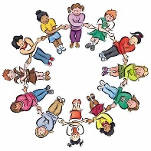
RELATIONSHIPS, SEX, HEALTH EDUCATION (RSHE, INCORPORATING PSHE) permeates all aspects of life in school. The RSHE curriculum is focused on educating how to have healthy relationships, minds and bodies. Children take part in a range of activities to give them the knowledge, skills and understanding they need to lead safe, confident and happier lives, empowering them to make good choices. During RSHE lessons we use the ‘Five to Thrive’ approach which encourages children to improve their well-being by being active, connecting, taking notice, giving and learning new things. School council and class discussions are held regularly giving opportunities for the children to solve problems in their everyday lives at school. The British Values of Democracy, the Rule of Law, Individual Liberty and Mutual Respect and tolerance are also fully embedded in our school ethos.

SEX EDUCATION is not specifically taught in school, although it is part of the RSHE and Science curriculum. Our aim is simply that children should gain age appropriate awareness of growth, reproduction, birth and death.

Parents who wish to discuss any aspect of the curriculum should make an appointment with the class teacher or Headteacher.

“Leaders’ high expectations for behaviour are seen throughout the school.”
Ofsted 2023

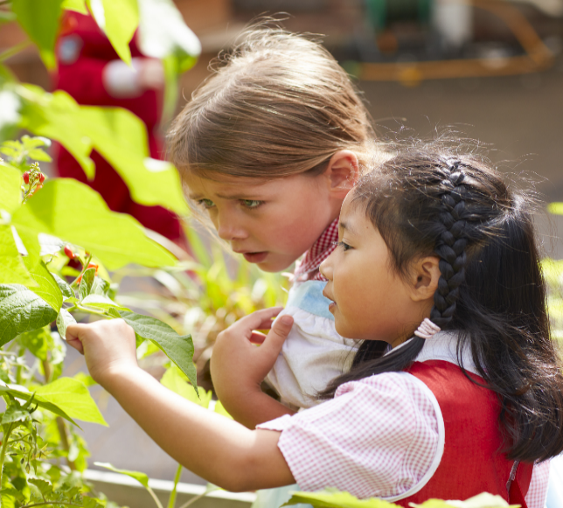
Special Educational Needs and Disabilities (SEND)

Many children at some time in their school life, experience difficulty in learning or with understanding their emotions, or they may have physical/medical needs which prevent them from accessing some activities as they would usually do. The underlying philosophy of Special Educational Needs and Disabilities provision in our school is ensuring equal access to education. We aim to identify and respond, at an early stage, to a pupil’s special educational needs. We actively involve our families and pre-schools in these discussions. We aim to provide support for any child who will benefit from small group teaching input or additional class based support, however slight or temporary their difficulties. This will ensure that all children access the curriculum and achieve the highest levels of attainment of which they are capable. Sometimes, this support can be met at class level, other times the child’s needs will need to be supported at SEN support level and the child will be placed on the school’s SEN register (with parental agreement).

The School complies with the national SEND Code of Practice which builds on the existing support systems and takes account of recent developments. School-based interventions are graduated so that appropriate support is given and help can be provided from outside agencies.
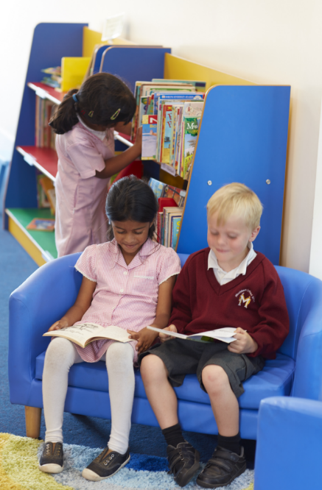

“Leaders ensure that disadvantaged pupils and pupils with special educational needs/ or disabilities are well supported across the curriculum”
Ofsted 2023

Parents are involved in setting up the support programmes and meet regularly with the staff concerned.
The school’s SEND provision is outlined in the school’s SEND Policy, which is available on our website. Details of arrangements which have been made for co-ordinating the day-to-day provision for pupils with special educational needs can be found in the SEND Policy document. Mrs Lindsey Patterson co-ordinates the SEND provision in the school. She can be contacted via the school office. Resources are allocated to meet the needs of the SEND pupils through individual and small group teaching. We support children from our school to the next and from the previous phases by working closely with SEND Coordinators from junior schools, nurseries and pre-school settings.

Facilities and arrangements to assist access to the school buildings, curriculum and social life for pupils with SEND include ramps to all school entrances and accessible toilets. Arrangements for the admission of pupils with SEND are outlined in the school’s admissions policy.

Training to support meeting the SEND within the school has covered supporting the variety of needs of our children. Whole school staff training covers improving in-class provision and adaptations to the curriculum. Pupils’ progress is reviewed through ongoing assessment and termly reviews of progress towards children’s targets in their person-centred plans. Links with other specialists/outside agencies include the Educational Psychologist, the Speech and Language Therapists, the Community Paediatricians and the School Inclusion Partners.

The school also enhances the opportunities for the More Able Child. Class teachers plan opportunities for children to deepen and extend their learning. The enquiry based curriculum allows pupils to challenge their thinking through discussion with peers and staff.

Extra-Curricular Activities

Year One and Two children are offered the opportunity to attend clubs such as Football, Tennis, Basketball, Gym and multisports.


Assessment
We use a range of techniques to assess the progress the children are making in order to support them effectively and to move forward with their learning. Children have a good knowledge of what they are doing well and what they need to do to improve. End of Early Years Foundation Stage assessments are reported to parents at the end of EYFS as a statutory requirement. Year 1 & Year 2 Teacher Assessments are reported to parents at the end of each year. Careful assessments and records of each child’s progress are shared with parents at regular intervals ensuring that a true partnership is fostered with parents/carers. These records are passed on to classes and schools at the appropriate time. Parents receive a detailed annual report and are encouraged to make their own responses to the report.

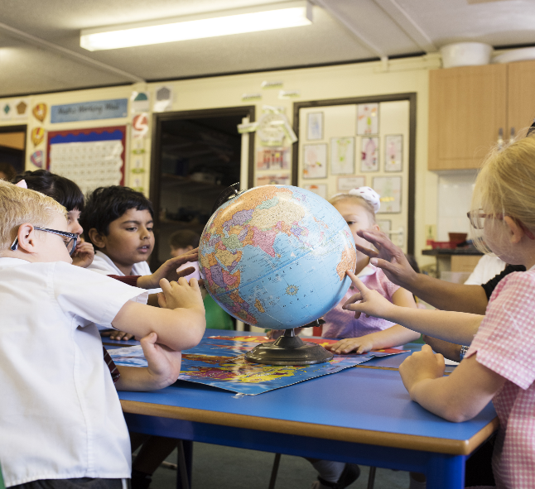

Homework Policy

A Reading Record book is sent home daily.
Children are encouraged to:
- read with their parents
- learn spellings and sounds
- undertake activities related to current school work
- play games at home to support their learning e.g. maths games
As the children bring reading books home on a weekly basis, nylon book bags are available to buy from the school office.

Professional Development

All staff, teaching and non-teaching, receive training in a variety of ways. Consultants and advisors work in school, alongside colleagues, and staff also attend courses offered by external training providers.
In addition, staff share their own expertise with other colleagues in school, through supporting and advising others, and leading staff meetings in their role as subject leaders.

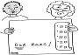
Pastoral Care, Discipline and School Code

We have a whole school approach to relationships and behaviour, with the same systems operating in every class.
Our Moulsham Code is designed to keep children safe and healthy and the buildings and school site in good order. Our Moulsham code is:-
- Speak nicely.
- Move calmly.
- Listen carefully.
- Act kindly.
- Stay safe.
If your child has any difficulties or you have any anxieties about your child’s life at school, it is important that these are resolved as soon as possible. Direct contact with your child’s class teacher should be made if a problem occurs. You may also discuss any problems with the Headteacher, and be confident that they will be fully investigated.

“Pupils benefit from the caring ethos of nurture and support in school”.
Ofsted 2023
Equality Policy

Equality includes all the protected characteristics covered under the Equality Act 2010 and we are committed to educating and developing all children whatever their creed, colour, race, or gender. We are an Inclusive School. The school has provided access for children and adults with disabilities with ramps, handrails and specially adapted toilets. Specialist teachers also give advice and support for specific pupils so that they can fully integrate into school life.

The school’s SEND policy outlines our plans for access to the school for those with disabilities.
This and all our policies are available for inspection in the school office.


Anti-Social Behaviour
If a child displays persistent anti-social behaviour, consultation is arranged between the teacher and parents so that an attempt can be made to understand the cause of the behaviour and to correct the matter. In the rare case of serious and persistent indiscipline, current policy permits exclusion from school. A detailed policy statement in this respect is available at school.
Both parents and children are encouraged to talk to teachers and the Headteacher if they have any concerns.


Inspection
All schools are subject to regular inspections by the Office for Standards in Education (OFSTED). Inspections take place according to agreed national standards monitored by OFSTED. Parents are sent a copy of the inspection report, which is published on the Ofsted website. An inspection of our school took place in April 2023. The school was graded as good in all areas. Copies of this report are available from the school office or on the internet at www.ofsted.gov.uk. or on the school’s website at www.moulsham-inf.essex.sch.uk.

Local Governing Body

The Local Governing Body is made up of a combination of appointed, elected, community and co-opted governors. This includes parents, staff, co-opted members and the Headteacher. They meet as a Governing Body on a half termly basis. The current Chair of Governors and the Company Secretary (Mrs Yasha Singh), can both be contacted via the school office.

“Governors carry out their statutory duties well”
Ofsted 2023

Child Protection
The Governing Body is legally responsible for ensuring that appropriate procedures are in place for the protection of children from abuse. The school has a specifically designated member of staff, who is available to discuss concerns about suspected child abuse, and who takes responsibility for setting the correct procedures in motion, if required.
All staff undergo training in this area, and there are regular visits from support services. In addition, the school takes seriously all safeguarding procedures, which includes, for example, Safer Recruitment.

“Safeguarding arrangements are effective”
Ofsted 2023

“The children always feel at the heart of this school. Thank you to all staff.”
Parent Survey 2023

School Security

We have sought advice from the Police and other organisations to provide a school which is as secure as possible. The whole site is monitored by a CCTV System which is regularly reviewed and maintained.
We are a secure site, with only one entrance and exit in normal use. However, emergency exits are readily available should the need arise. The premises are alarmed in an effort to protect them against criminal activity. Children are encouraged not to bring valuable items to school.
Children are not allowed to go home with adults other than their primary carer/s unless we have received advance notice, either in writing, verbally at the front door or by telephone.
Smoking is not allowed on site.
“Pupils feel safe in school. They know how to keep themselves safe in and out of school, as well as online”
Ofsted 2023

School Support Services

Our school is served by a variety of support services, which include:

- Family Support Worker
- a school nurse
- counsellor
- an Educational Welfare Officer
- an Educational Psychologist
- a speech and language therapist
- specialist teachers
All play an important role in the life of the school.

Whole School Achievements




Our school has numerous awards which reflect and celebrate our aims and ethos. We were pleased to receive a national award from Sport England. ‘Active Mark’ is an accreditation programme which recognises schools that show a commitment to promoting physical activity.

We have also been recognised as an advanced award Healthy School. This acknowledges our work on promoting a healthy lifestyle. We gained the International Intermediate award, in recognition of the global aspects included in our curriculum, as well as for our links with schools/organisations abroad. The school has been awarded an Artsmark gold award from the Arts Council. This award acknowledges the commitment the school has to providing a rich and varied arts education. We have also been awarded a Level 1 certificate in Sustainable Learning. This was in recognition of our continued effort to reduce the amount of energy we waste in school.


Admissions
All applications for reception places including catchment applications for the start of the academic year are processed by the Local Authority at www.essex.gov.uk. Mid-year applications for any year group should be made directly to the school. A form is available on our website www.moulsham-inf.essex.sch.uk under the ‘Information tab, Admissions, Mid-year application form’.
Parents seeking a place for a child starting school should ensure that they make an application before 15th January 2026, the closing date for applications. In addition, although not essential, we would also appreciate parents/carers making a direct application to the school. Please contact the school office for application forms.
Visits to the school are always welcome and should be booked through the school office. If any further advice is needed please do not hesitate to contact us.

The School Day
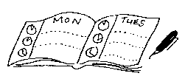
Children enter the school between 8.35 a.m. and 8.45 a.m. Registration is taken at 8.45 a.m. EYFS children enter via the side gate and Year 1 and 2 children through the main front door. We ask that children and parents/carers wait away from the bottom of the steps until the main front door opens. To ensure a smooth start to the day, Mrs Landa-Arrese and several teaching assistants are waiting at the front door/side gate to greet the children. An adult at the door/side gate has a book in which all messages from parents are recorded, such as changes to collection arrangements. Children in EYFS learn through a mixture of teacher-led sessions and continuous provision where they learn through play, supported by teachers and LSAs. In Key Stage 1 (Years 1 and 2), the approach is slightly different and the children have a set playtime every morning at 10.30 a.m. for 15 minutes. All classes leave school at 3.15 p.m.

School Attendance
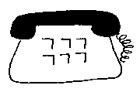
If your child is unable to attend school due to illness, please telephone the school on the FIRST DAY OF ABSENCE. This is known as First Day Contact.
If you have not notified the school by 9.15 a.m. on the First Day of Absence, the school MUST be able to contact you.
If your child has had sickness or diarrhoea please allow 48 hours after the last bout before returning to school. The registers close at 9.10 a.m. and if your child arrives after that time they receive a mark that shows they are on site but the session is marked as an unauthorised absence. Full details are available in our Attendance Policy on our website.
If your child requires medication during the school day, you will need to make arrangements to call into school to administer the medicine. The school staff are unable to administer any medication.
Parents are not permitted to take their children out of school for holidays during term time. Under amendments to the 2006 Education Regulations, Headteachers may not grant any leave of absence during term time unless there are exceptional circumstances. A form is available from the lobby requesting absence which must be completed by the parent or guardian AT LEAST 4 WEEKS before the date of absence. There is also a form requesting absence for medical/dental/religious observance or compassionate grounds. Please see website for details of our absence policy at www.moulsham-inf.essex.sch.uk. Copies of the forms are also available on the website.

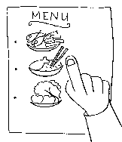
Lunchtime
All children in the school are entitled to a free hot school meal/or sandwich option. We ask that you pre-order meals 3 weeks in advance. Meals offered are freshly prepared using the best quality ingredients and local produce. Menus meet nutritional standards and are available on our website. Children may also bring a packed lunch from home if they prefer. Milk is available for all children at lunchtime, free of charge. Water is also available.




Snacks
Under the Government Fruit Scheme, fruit is provided as a mid-morning snack for all children. However if children prefer they may bring a snack from home. It must be either fruit or vegetable and eaten without help from an adult i.e. – it doesn’t need cutting up. NB grapes should always be cut in half to avoid choking. The snack should be kept either in their lunch box or a small box / container in their book bag
’Snacktime’ is a positive part of the children’s schooling as we encourage the importance of hand hygiene, eating healthy food and good manners.

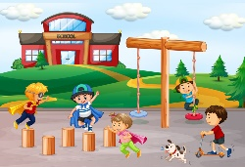
School Grounds
Our school grounds offer a safe, secure and spacious environment for your children. Our redeveloped outdoor areas have play equipment, a climbing wall, a running track, a football pitch, a selection of outdoor gym equipment, a forest area leading into a gazebo, a large grass area, a large hard surface area and lots of seating beneath the trees. The children have space for very active games, as well as shaded, seating areas for quieter activities. Each year group also has its own outdoor area which is used to support the curriculum. We also have a memorial garden where children can sit quietly in peaceful surroundings.

Transfer to Junior School

All children from Moulsham Infant School are guaranteed a place in Moulsham Junior School as long as they have applied for a place by the 15th January preceding the academic year of admission. Parents will be required to apply for a Year 3 place through the Local Authority between 4th November 2025 and 15th January 2026.

The partnership between Moulsham Infant and Junior schools helps to support the aim of ensuring that a child’s primary education is continuous. Children move from our school (Key Stage 1) to the Junior School (Key Stage 2); a planned transition programme prepares them for the following year. This includes visits to the Junior school for assemblies, special curriculum weeks and a classroom visit to meet their new teachers and help them gain confidence in the new environment. Full academic records are passed from the Infant to the Junior school. Joint planning and consultation between the two Headteachers and staff ensure curricular continuity.
“It is amazing to hear my children’s stories every day about what they have learnt or the exciting activities they have done”.
Parent Survey 2023

SMILE

The Parent-Teacher Association (PTA), Support Moulsham Infants’ Learning Experience (SMILE) supports the school. SMILE arranges social functions and fund-raising activities throughout the year. All parents are automatically members of SMILE and during the Annual General Meeting, parents may nominate themselves as members of the committee. Fundraising by SMILE has had a tremendous impact on the facilities provided for the children in our school.

Community Links

Moulsham Infant School works closely with Moulsham Junior School who are on the same site and Oaklands Infant School. The three schools work closely together to ensure continuity for the children who are educated within the local community. We have very close links to the pre-school providers in the area to ensure a smooth transition from pre-school into main stream school. Our facilities (e.g. Computing suite, school field etc.) are used by some of the pre-school providers. We have regular visits from local services within the community, including the school nurse, local clergy and police. Professional Active Soccer School (P.A.S.S) and CMXC also work within the school at times throughout the school year.

Parents/Carers in School

“At break times, the pupils play nicely together. They have fun while sharing the many playground activities”
Ofsted 2023
Parents, Carers and grandparents are very welcome in school subject to a Disclosure & Barring Service check (DBS) through the school. Information is available from the school office regarding this process.
At Moulsham Infant School, we place strong emphasis on home/school co-operation, and carers:
- help in classrooms
- play games
- help in the school library
- help escort children on educational visits
- help in the crèche during class assemblies
- help with special events and any organised curriculum days
- help to make resources and games and cover books
We believe that this degree of co-operation strengthens the links between the home and teachers, and the children benefit a great deal from talking to and working with other adults.

“There is a good emphasis on personal and social development, balanced with a wide curriculum.”
Parents Survey 2023

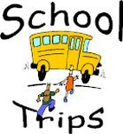

Educational Visits and Visitors
We believe that educational visits and visitors into school provide an important extension to classroom work. Children are able to develop their learning through first-hand experience of their local environment and beyond. Parents are often invited to share in these experiences, joining school visits to farms, museums and other places of interest.

We ask parents to make a contribution towards the cost of transport and entrance fees. No child is ever excluded from the educational value of an activity because of the parent’s inability to contribute. However if we do not receive sufficient funds to cover the costs of school visits then they will be cancelled. Parents will be notified of all visits and permission will be requested for each educational trip.


Charging and Remissions Policy for Additional Activities

We rely on parental contributions to maintain educational visits and occasional visits by theatre and music groups etc. A policy document on Charging and Remissions for Additional Activities is available on our website at www.moulsham-inf.essex.sch.uk.

Privacy Notices
All our Privacy Notices can be found on our website at www.moulsham-inf.essex.sch.uk under the School Information tab, Key Policies & Reports, Data Protection Privacy Notices.

“.The opportunities to come into class for mindfulness sessions, open afternoons, are special for parents”
Parents Survey 2023

If you cannot access the internet please contact the school office and paper copies will be provided.

School Information – complaints procedure

Copies of curriculum and organisational documents are available for your inspection. The Headteacher and class teachers plan to provide your child with the very best education, and try to overcome any problems that may arise through informal discussions. If this fails to produce a satisfactory outcome, the Governing Body is also there to assist you and may be contacted through the school office. If concerns cannot be resolved by informal discussion or through the Governing Body there is a complaints procedure for Academies through the Secretary of State in the Department for Education under Section 496 of the Education Act 1996. Details are available in the school office.



School Uniform
All children in the school wear school uniform and full details will be given prior to entry in the school handbook.

“Staff love working at Moulsham Infant School”,
Ofsted 2023

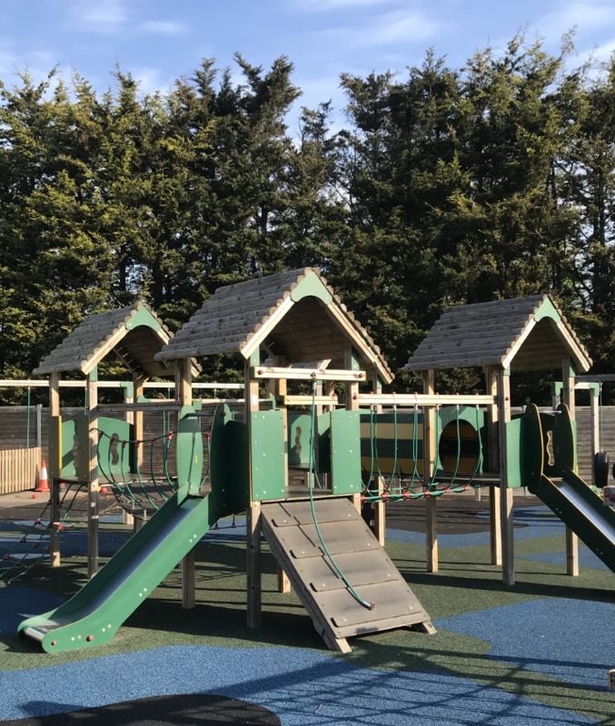
PLEASE NOTE
Backpacks are not allowed in school as they
become a Health and Safety issue as a trip
hazard in cloakrooms. Thank you for your
understanding in this matter.

“Pupils are polite and respectful to adults and each other. Relationships are strong.”
Ofsted 2023

School dogs
We have 1 dog that is attached to the school. Mrs Palmer’s dog Bonnie is an Australian Labradoodle. Bonnie will sometimes be in school and the children may have contact with them – this will be with parents’ consent.

Home/School Commitment
Note from the Headteacher

I hope you have found this prospectus useful and informative. We are all very proud of our school and what we achieve. Please contact us via the school office if you have any further questions.

At Moulsham Infants, we view your child’s education as a partnership between home and school. Parents, children and the school all have the following rights and responsibilities and we request that all members of our school community follow them.

The Parents/Guardians will:-

- Ensure my child arrives at school on time (8.35 a.m. - 8.45 a.m.) and is collected promptly at 3.15 p.m.
- Ensure my child attends school regularly – telephone the school or send a message on the first morning of absence to inform the school of impending absence
- Work in partnership with the school and help maintain the ethos and standards portrayed in the School’s Prospectus
- Attend parents’ evenings to discuss my child’s progress
- Work with the school to support its approach to good pupil behaviour
- Support the school in the implementation of its Homework Policy
- Inform the school should any particular circumstance occur at home which may have a direct effect on my child’s school performance
- Discuss this document with my child

The school will:-
- Provide high quality education for all its pupils
- Provide a curriculum that is both broad and balanced
- Meet the needs of all pupils according to their individual abilities
- Make a commitment to work in partnership with parents
- Inform parents of their child’s progress at regular intervals throughout the school year
- Encourage children to be kind and thoughtful to others
- Encourage children to take care of school buildings and equipment
- Encourage children to be independent and give them the skills to move through life with confidence
- Play a part in the local community
- Keep parents informed of school activities
- Support children in their social and moral development
- Ensure that the children are happy in school

The child will:-
- Treat other people as I would like them to treat me
- Take responsibility for my work and actions
- Work hard and always try to do my best
- Move around the school thoughtfully and carefully
- Respect property belonging to other people or the school
- Be polite and considerate to others
- Be honest – always tell the truth
- Show care for the environment
- Remember that there is a time for listening and a time to speak
- Follow the Moulsham Code.

